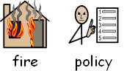**Fire safety staff procedures**

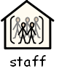Our emergency evacuations procedures are as follows:

**Staff & volunteers procedure in event of fire being detected**

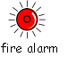

* Sound the alarm (if not already done).
* 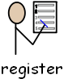Registration / signing in staff is required to check how many children have signed in to enable a headcount, taking the laptop with them.
* 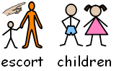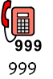All children, visitors, parents, carers are escorted out of the building to the assembly point (boat). Indoor staff A (register staff) will clear the play room and mezzanine. They will check the pirate ship on their route out. They will then exit to the boat to conduct a head count and Indoor staff B (float or kitchen staff) will check all side rooms, closing fire doors behind them then go to the front of the building to stop public entering the building and wait for the fire department. Outdoor staff will guide all children and parents to the fire evacuation point and conduct a sweep of the field.
* 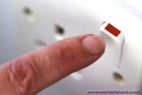If safe to do so, kitchen staff should turn off the cooking appliance and ventilation switches at the rear of the kitchen. Ensure that you have informed staff what you are doing.
* The designated fire marshal should assume their duties:
* 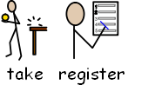Ensure the fire service has been contacted.
* Collect register and conduct head count.
* 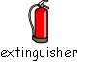If trained and if safe to do so, use the fire extinguisher to put the fire out. Ensure that you have informed staff what you are doing so that you are accounted for.

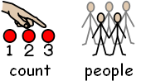

* When safely assembled, check all people are accounted for.
* http://vipdictionary.com/img/wait_l.gifDo not return to the building until the fire service say that it is safe to do so.

**NOMINATED FIRE MARSHALS:**

* Ella Blewitt, Sycamore Adventure manager
* Will Ganniclifft, senior play ranger
* Ash Sadlier, Free 2 Play lead
* Glen Flurry, Free 2 play lead

**Additional information:**



Sycamore Adventure staff and volunteers will follow the above procedure in the event of a fire. They will also adhere to the points below:



1. Fire instructions are clearly displayed on the premises, (poster displayed at each fire point and exit). *See page 3*
2. 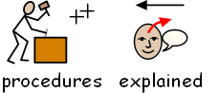Fire procedures are explained to all new members of staff and volunteers upon initial induction.

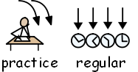

1. Fire drills are practiced regularly (at least twice per year).
2. 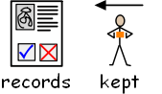Records are kept of fire drills and the servicing of fire safety equipment.



1. Weekly internal checks are held on the fire alarm system, evacuation routes, fire doors and firefighting equipment.

[](https://www.google.com/url?sa=i&url=https%3A%2F%2Fwww.keysigns.co.uk%2Fsigns-c2%2Fsafety-signs-c3%2Fmandatory-signs-c58%2Faccess-safety-signs-c59%2Fkeep-clear-signs-p280&psig=AOvVaw0E1d_ZNLwUYZFmFDflk8a8&ust=1588161677407000&source=images&cd=vfe&ved=0CAIQjRxqFwoTCLDphriJi-kCFQAAAAAdAAAAABAE)

1. Fire doors / escape routes are kept clear of clutter / litter, ensuring safe route from building.

[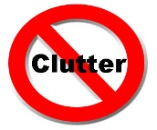](https://www.google.com/url?sa=i&url=https%3A%2F%2Fkellysthoughtsonthings.com%2Ftips-creating-clutter-free-shop-front%2F&psig=AOvVaw0NXbhFjPJMNlhdBMwh7uZK&ust=1588161755483000&source=images&cd=vfe&ved=0CAIQjRxqFwoTCIjEht6Ji-kCFQAAAAAdAAAAABAD)

1. Sources of ignition are kept away from the public and the site is secured when not in use to avoid people having access to the grounds and reduce the risk of Arson.

[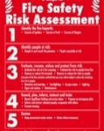](https://www.google.com/url?sa=i&url=https%3A%2F%2Fwww.rvfiresystems.co.uk%2Fclitheroe-fire-risk-assessment%2F&psig=AOvVaw3cM4eOp_IFhl6otejZtkVN&ust=1588161808496000&source=images&cd=vfe&ved=0CAIQjRxqFwoTCLDYmfmJi-kCFQAAAAAdAAAAABAD)

1. Sycamore Adventure will adhere to its fire risk assessment (last conducted May 2021).

[](https://www.google.com/url?sa=i&url=https%3A%2F%2Fwww.wm.edu%2Foffices%2Fdeanofstudents%2Fservices%2Fcaresupportservices%2Findex.php&psig=AOvVaw1mq0dpDcna6lQOWg9FNVDA&ust=1588161942594000&source=images&cd=vfe&ved=0CAIQjRxqFwoTCKj_s7uKi-kCFQAAAAAdAAAAABAD)

1. Any clutter / damaged fire doors / unsealed fire extinguishers / faulty electrical equipment / sources of ignition should be reported to the manager immediately.

[](https://www.google.com/url?sa=i&url=https%3A%2F%2Fwww.nidirect.gov.uk%2Fnews%2Fhelp-available-if-you-want-quit-smoking&psig=AOvVaw0pHqU_u2bWQjIL0J1OMFYA&ust=1588162061134000&source=images&cd=vfe&ved=0CAIQjRxqFwoTCLCM9O6Ki-kCFQAAAAAdAAAAABAD)

1. Smoking is a significant fire risk and as such Sycamore Adventure is a no smoking environment. Any signs of smoking taking place should be reported to the manager.

[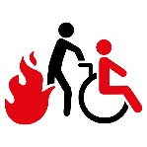](https://www.google.com/url?sa=i&url=https%3A%2F%2Fcompliplus.com%2Fsafety-training%2F9-training-courses%2F38-fire-evacuation&psig=AOvVaw0PSLfEM9FjN8l_8D7gMtLN&ust=1588162266897000&source=images&cd=vfe&ved=0CAIQjRxqFwoTCICXmtKLi-kCFQAAAAAdAAAAABAJ)

1. Staff and volunteers who need support evacuating in the event of a fire will need a Personal Emergency Evacuation Plan (PEEP) completed.

**[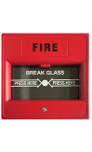](https://www.google.co.uk/url?sa=i&rct=j&q=&esrc=s&source=images&cd=&cad=rja&uact=8&ved=&url=https://play.google.com/store/apps/details?id%3Dcom.Almaksoft.BreakGlassToSoundAlarm&psig=AFQjCNHLOyeux9B6TLKoAgZvOiRZFtOQVw&ust=1485347180972117)Fire safety staff procedures**

* Sound the alarm
* [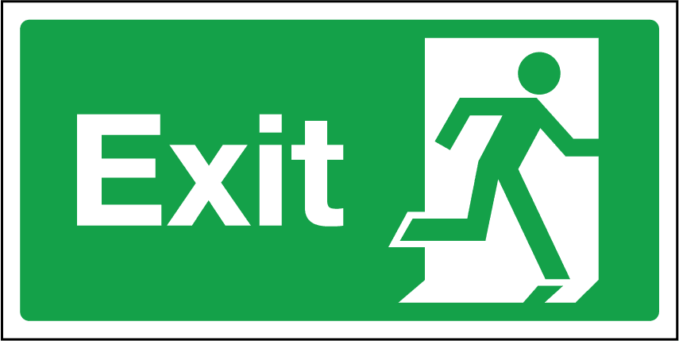](https://www.google.co.uk/url?sa=i&rct=j&q=&esrc=s&source=images&cd=&cad=rja&uact=8&ved=0ahUKEwjd18qo5NrRAhXIkSwKHaC4DuAQjRwIBw&url=https://teachbytes.com/2013/09/15/10-ways-to-create-digital-age-exit-tickets/&psig=AFQjCNEPEhTkS4JkLMsG1E_z7kjtSvYxbQ&ust=1485347286578760)Leave the building via your nearest exit. Leave all of your belongings behind
* [](https://www.google.co.uk/url?sa=i&rct=j&q=&esrc=s&source=images&cd=&cad=rja&uact=8&ved=0ahUKEwij2Nn95NrRAhVLkSwKHayNDAMQjRwIBw&url=https://quitsmokingcommunity.org/how-to-help-someone-quit-smoking/&bvm=bv.144686652,d.bGg&psig=AFQjCNGta5CZyJn3CRLrzS8bXYCHKvZB3A&ust=1485347551590057)Our staff will help everyone to exit the building safely and conduct a sweep of the building
* [](http://www.google.co.uk/url?sa=i&rct=j&q=&esrc=s&source=images&cd=&cad=rja&uact=8&ved=0ahUKEwj2sPvm5drRAhVBCSwKHULQC4YQjRwIBw&url=http://www.sabc.co.za/news/tag/Missing&bvm=bv.144686652,d.bGg&psig=AFQjCNHyoKUSb59JkVwriZTUxewl3uQrQA&ust=1485347707337066)Locate your friends and family. Please let a member of staff know if you are aware of anybody who is missing. Staff will inform emergency services.
* 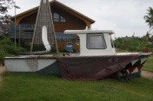Meet by the boat in the play area. If the fire’s position requires you to exit to the front of the building, meet by the yellow double gates in the corner of the field.
* [](http://www.google.co.uk/url?sa=i&rct=j&q=&esrc=s&source=images&cd=&cad=rja&uact=8&ved=0ahUKEwin9eKk59rRAhUMESwKHXROANkQjRwIBw&url=http://www.actuariesindia.in/registration.aspx&psig=AFQjCNFIbGl_N9_gaoUyZTdJHoyK4wMgrA&ust=1485348161054772)Stay at the fire evacuation point until the staff have read the register to ensure that everyone is accounted for.
* [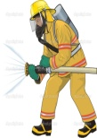](https://www.google.co.uk/url?sa=i&rct=j&q=&esrc=s&source=images&cd=&cad=rja&uact=8&ved=0ahUKEwiyiNDI6NrRAhUF3CwKHVgCDPIQjRwIBw&url=https://www.tes.com/lessons/H62jm0hVCvd09A/fireman&bvm=bv.144686652,d.bGg&psig=AFQjCNGb3_JVt8JYGZjKgZW1Hx964Ra6ZA&ust=1485348447795089)[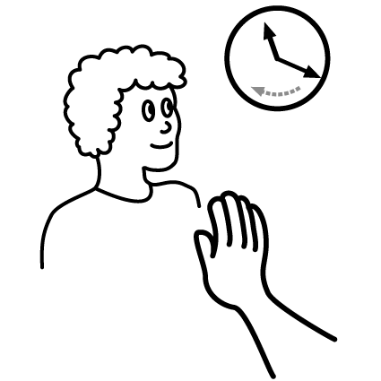](http://www.google.co.uk/url?sa=i&rct=j&q=&esrc=s&source=images&cd=&cad=rja&uact=8&ved=0ahUKEwi9lOKL6NrRAhXB3iwKHerUBHsQjRwIBw&url=http://www.heuning.co.za/bybelstudie%20wait.htm&bvm=bv.144686652,d.bGg&psig=AFQjCNG26bdocERgQlTUlWezl7Bw5fBQ-w&ust=1485348352425342)Do not re-enter the building until emergency services have said that it is safe to do so.